**LEBANESE AMERICAN UNIVERSITY**

**USAID – HIGHER EDUCATION SCHOLARSHIP PROGRAM**

**HES - Volunteering Program Verification Form**

This form is to be used to document volunteering hours. If a student volunteers for multiple organizations, a separate form must be used for each organization. **This form must be turned in by the 28th of each month, the latest.**

I certify that the scholar Razan Zwein completed a total of 2 hours of service at InnovaThrive.

The hours were completed hours as per the below:

Hours # 2 (date) _2/12 – 6/12_ (initials of supervisor) __A.K.___

Hours # 0 (date) _9/12 – 13/12_ (initials of supervisor) __A.K.___

Hours # 0 date) _16/12 – 20/12 (initials of supervisor) __A.K.___

Hours # 0 date) _23/12 - 27/12 (initials of supervisor) __A.K.___

Brief description of the activities the scholar performed or participated in:

Research on cancer, how to prevent it and what could possibly be done to avoid it

Written feedback about the scholar’s performance:

Razan Zwein’s research on cancer prevention demonstrated valuable insight, though the submission of the volunteering form was delayed. Late submissions are not acceptable, and it is important to adhere to deadlines in future activities to ensure proper coordination.

Please rate the overall performance of the scholar at your organization:

|  |  |  |  |
| --- | --- | --- | --- |
|  | Mastery (5) | Proficient (3) | Emerging (1) |
| **Problem solver** | X |  |  |
| **Engaged & Committed** | X |  |  |
| **Open-minded & multicultural** | X |  |  |

Signature

& stamp

__________________________

_

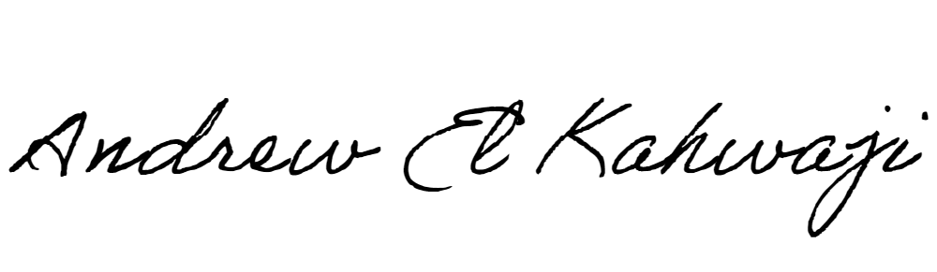

Printed Name _Andrew El Kahwaji_

Date __26/12/2024___

Email __andrew.lifesculptor.coo@gmail.com __

Phone __+961 71 914 378__